**UJIAN AKHIR SEMESTER (UAS)**

Nama : Irvan Arsena

NIM : 20030027

Prodi : Informatika (IF)

Mata Kuliah : Pemrograman Mobile

1. Use Case Diagram “MyNilai_IrvanArsena”

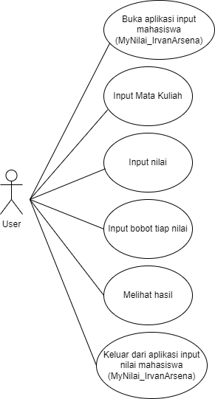

1. Class Diagram

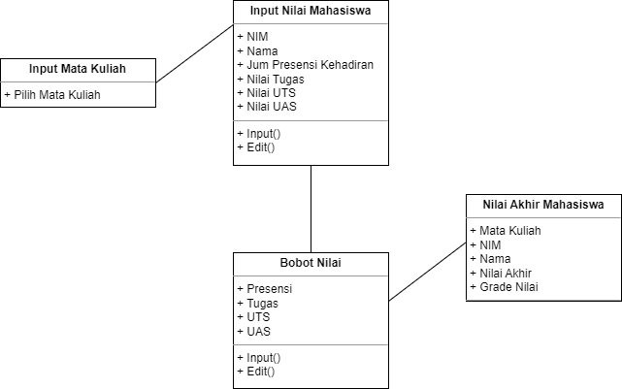

1. Activity Diagram “MyNilai_Irvan Arsena”

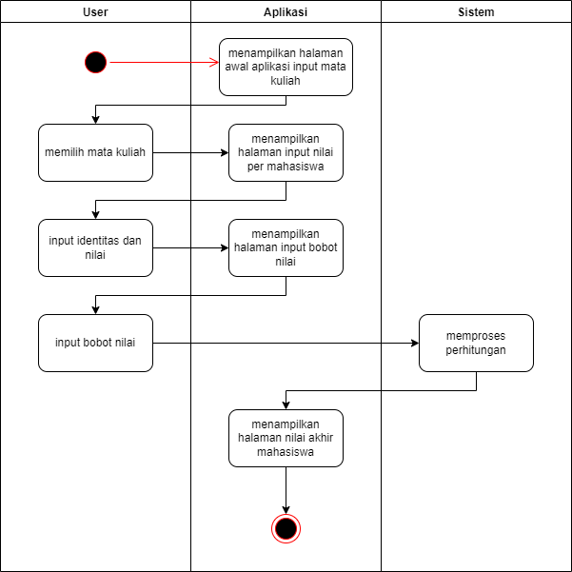

1. Sequence Diagram

